Assignment No. 3

GRN:12111038
Name of the Student:Pratik Masani
Roll No.:21
Class:ET-C
Division:C
Batch:1

Problem Statement

Calculate area of triangle, square & circle using function overloading. Function parameter accept from user. Create Base Class Shape and Derived Classes Triangle, Square, Circle respectively. Implement getInputs() Method for accepting inputs, and Overload setArea() method for calculating area of respective shapes.

Use Class Tester for creating objects.

Sample Input and Output

Sample Input/Parameter for Triangle | Values | Expected Output
Height (H) | 50 | 2500
Base (B) | 100 | 2500

Sample Input/Parameter for Circle | Values | Expected Output
π (Pie) | 3.14 | 7853.98
Radius (R) | 50 | 7853.98

Sample Input/Parameter for Square | Values | Expected Output
Side (S) | 15 | 225

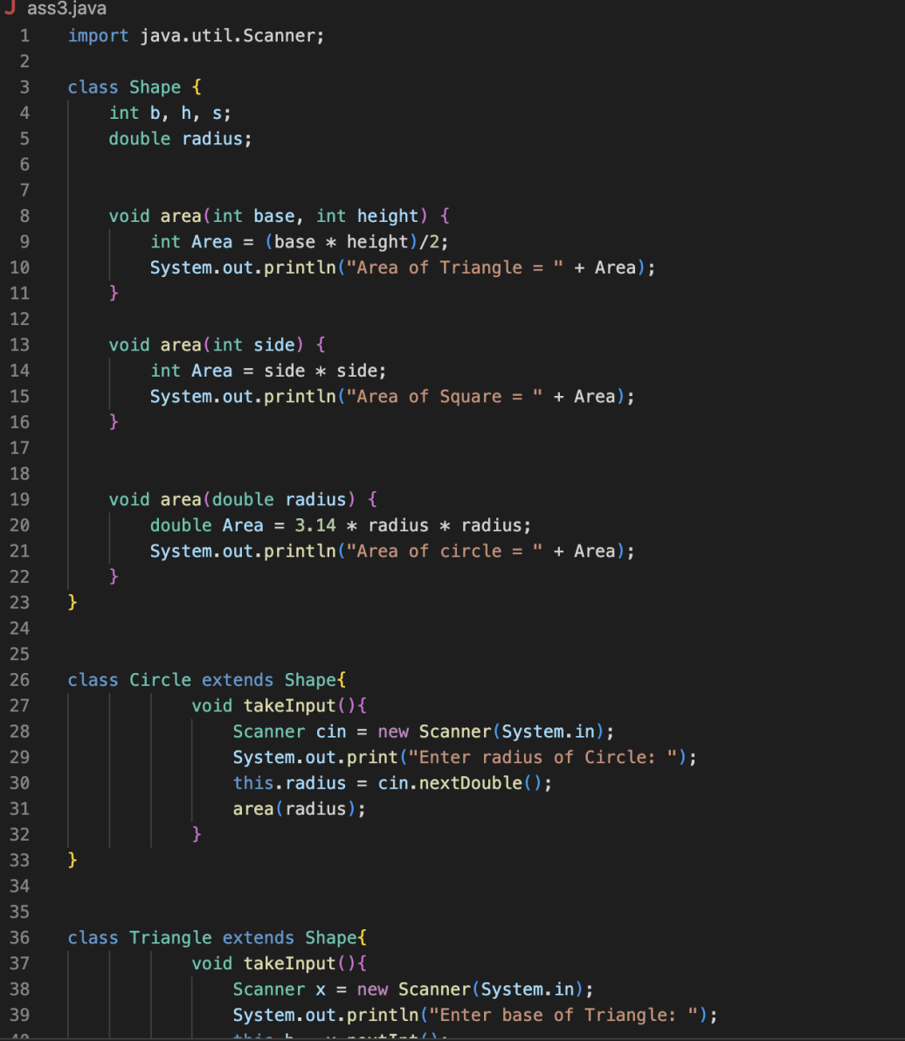

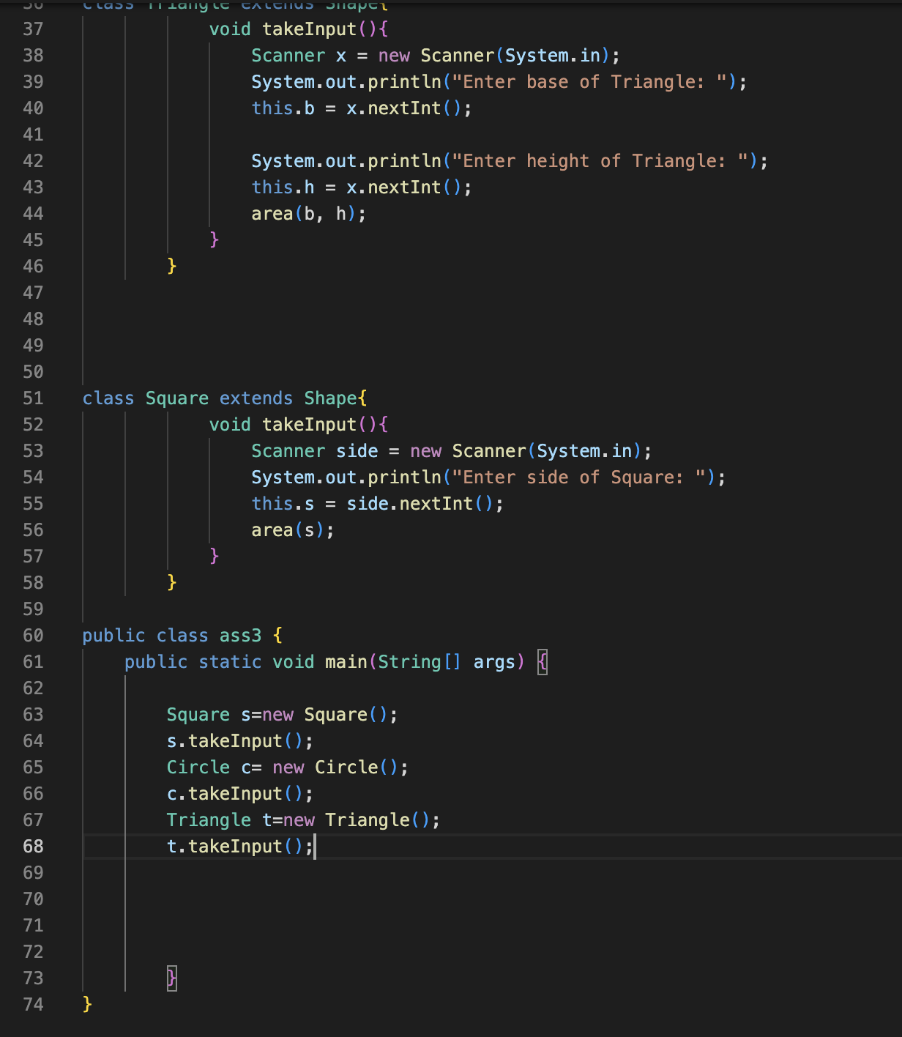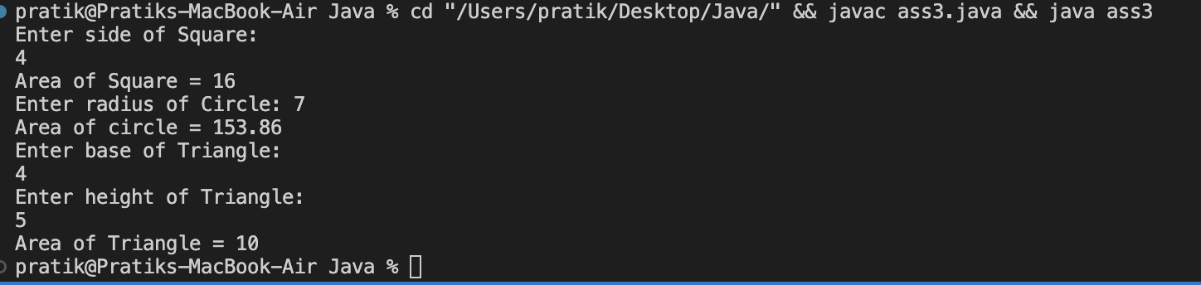

Expected Output:

